Gibb’s Free Energy

1. You can combine ΔH and ΔS to predict whether a given reaction occurring at a constant temperature and pressure will be spontaneous. Gibb’s Free Energy is the maximum amount of energy released from a system that is available to do work on the surroundings.

2. ΔG = ΔH – TΔS Where T is temperature in Kelvin..

3. Under standard conditions (remember the way it naturally exists at 1 atm and 25C, 1M)
ΔGº = ΔHº – TΔSº
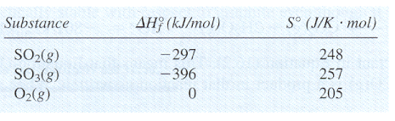
Exercise 9 Calculating ∆H°, ∆S°, and ∆G°

Consider the reaction
2SO₂(g)+O₂(g)→2SO₃(g)

carried out at 25°C and 1 atm. Calculate ∆H°, ∆S°, and ∆G° using the following data:

∆H° = -198 kJ
∆S° = -187 J/K
∆G° = -142

4. ΔG rules above ΔH or ΔS. If:
ΔG is negative, the reaction is spontaneous in the forward direction
ΔG is 0, the reaction is at equilibrium
ΔG is positive, the reaction is not spontaneous in the forward direction, but is spontaneous in the reverse direction.
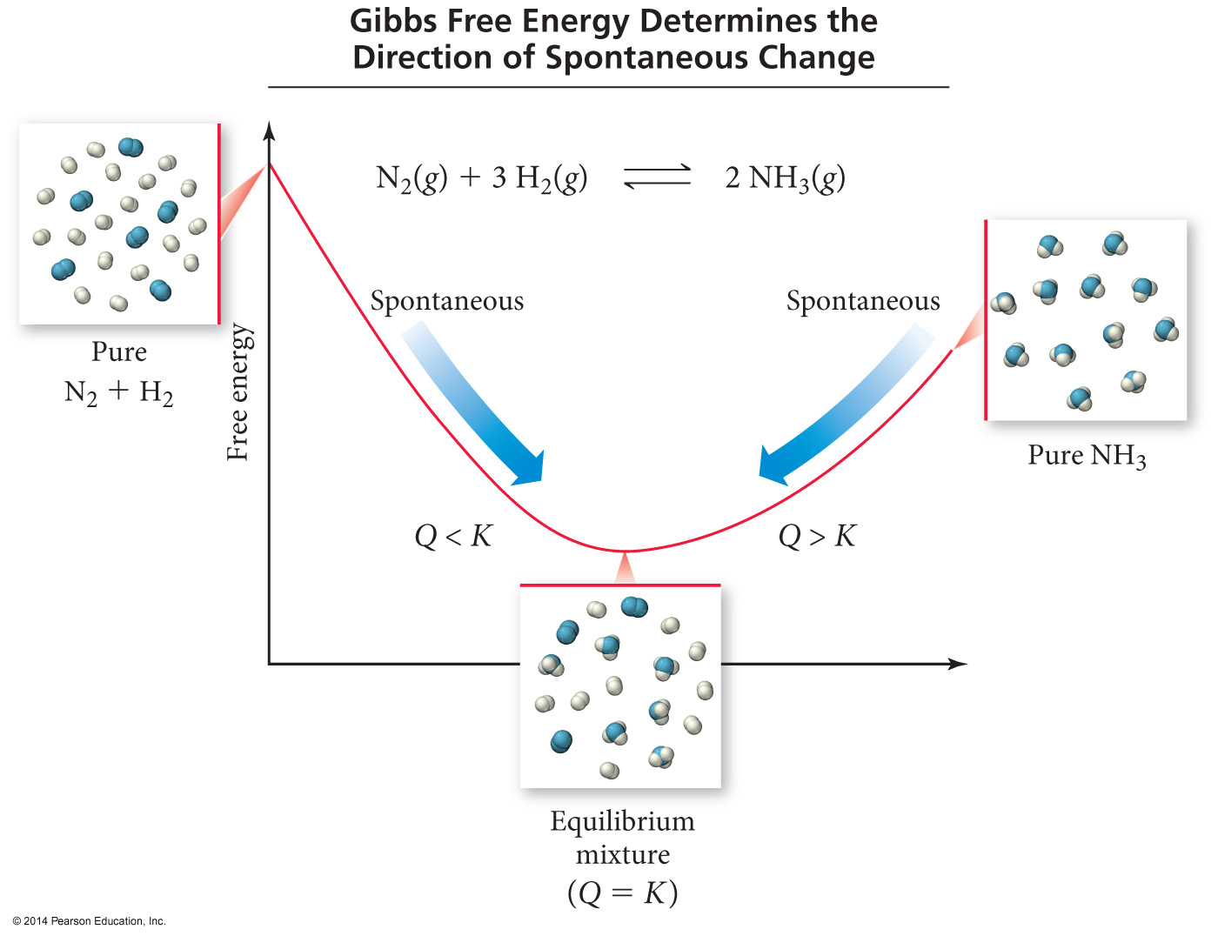
∆G⁰ | K
∆G⁰ = 0 | K = 1
∆G⁰ < 0 | K > 1
∆G⁰ > 0 | K < 1

5. ΔG is a state function like ΔH and ΔS. That means:
ΔG_{rxn} = Σ ΔG _{(products)} - Σ ΔG _{(reactants)}
Sample Problem C:
Find the free energy of formation for the oxidation of water to produce hydrogen peroxide.
2 H₂O_{(l)} + O_{2(g)} → 2 H₂O_{2(l)}
Given the following information:
ΔGº_{f}
H₂O_{(l)} -56.7 kcal/mol
O_{2(g)} 0 kcal/mol
H₂O_{2(l)} -27.2 kcal/mol

Answer: 59.0 kcal/mol

6. It also means that it works like ΔH in Hess’ Law.

Exercise 10 Calculating ∆G°
Using the following data (at 25°C)

C_{diamond}(s)+O₂(g)→CO₂(g) ∆G°= -397 kJ
C_{graphite}(s)+O₂(g)→ CO₂(g) ∆G°= -394 kJ

Calculate ∆G° for the reaction
C_{diamond}(s)→C_{graphite}(s)

= -3 k
SUMMARY OF FREE ENERGY:
ΔG = + NOT SPONTANEOUS
ΔG = - SPONTANEOUS

Conditions of ΔG:
ΔH ΔS Result
negative positive spontaneous at all temperatures
positive positive spontaneous at high temperatures
negative negative spontaneous at low temperatures
positive negative not spontaneous, ever

7. External sources of energy can be used to drive change in cases where the Gibbs free energy change is positive.
a. Electricity may be used to cause a process to occur that is not thermodynamically favored. Useful examples are charging of a battery and the process of electrolysis.
b. Light may also be a source of energy for driving a process that in isolation is not thermodynamically favored. Useful examples are as follows:
1. The photoionization of an atom, because although the separation of a negatively charged electron from the remaining positively charged ion is highly endothermic, ionization is observed to occur in conjunction with the absorption of a photon.

2. The overall conversion of carbon dioxide to glucose through photosynthesis, for which
6 CO₂(g) + 6 H₂O(l) → C₆H₁₂O₆(aq) + 6 O₂(g) ΔG° = +2880 kJ/ molrxn,
yet is observed to occur through a multistep process that is initiated by the absorption of several photons in the range of 400–700 nm.
c. A thermodynamically unfavorable reaction may be made favorable by coupling it to a favorable reaction, such as the conversion of ATP to ADP in biological systems. In this context, coupling means the process involves a series of reactions with common intermediates, such that the reactions add up to produce an overall reaction with a negative delta G.

